**NRP 2.0**

**User Manual for Connect Boarding Application (CBA)**

User manual update

Date of last update: 2022, March 17th

|  |  |  |
| --- | --- | --- |
| Date | Name of editor | Updates |
| 2021 March | Dana Vlkova | Document created |
| 2021 November 10th | Dana Vlkova | Release 202113 added |
| 2022 March 17th | Dana Vlkova | Release 2022.02 added  Power Pass info:   * Chapter 1 updated * Figure 14 updated * Figure 15 updated |

Table of Contents

1. Connect Boarding Application – definition and purpose 6

2. Connect Boarding Application – roles and access rights 6

2.1. Roles 6

2.2. Access rights 6

3. Connect Boarding Application – Home Page navigation 7

3.1. Header 7

Figure 1 - Header 7

3.2. Footer 7

Figure 2 - Footer 7

3.3. CBA Dashboard - description 7

3.4. CBA Dashboard - filters 7

Figure 3 – Default Filters 7

Figure 4 – Additional Filters 8

3.5. CBA – search for customers 8

Figure 5 – Search Field and Results 9

4. Connect Boarding Application – Create New Customer 9

Figure 6 – “Create new Customer” button 9

Figure 7 – Email Field 9

4.1. Customer Information 10

Figure 8 – Customer Information 10

4.2. ŠKODA Ident 11

Figure 9 – ŠKODA Ident 11

Figure 10 – ŠKODA Ident – Issue Date, Expiration Date, Date of Birth 12

4.3. Order Details 13

Figure 11 – Order Details 13

Figure 12 – ŠKODA Ident – Production Date, Handover Date 13

4.4. Consent Verification 14

Figure 13 – Consent Verification 14

4.5. Customer Journey 14

Figure 14 – Customer Journey Screen 15

5. Connect Boarding Application – Edit Customer Details 16

Figure 15 – Edit Customer Information Starting Page 16

5.1. Change Order Details 16

Figure 16 – Change Order Details 17

5.1.1. Change VIN Number 17

5.1.2. Change Production Date 17

5.1.3. Change Handover Date 17

5.1.4. Change Preferred Service Partner 17

5.1.5. Select Service Scheduling 17

5.2. ŠKODA Ident 17

Figure 17 – Change ŠKODA Ident 18

5.3. Customer Information 18

Figure 18 – Change Customer Information 18

5.3.1. Change Email 19

5.3.2. Change Salutation 19

5.3.3. Change First Name 19

5.3.4. Change Last Name 19

5.3.5. Change Middle Name 19

5.3.6. Change Nickname 19

5.3.7. Change Country 19

5.3.8. Change Address Type 19

5.3.9. Change Preferred Language 19

5.3.10. Change Street 19

5.3.11. Change Number 19

5.3.12. Change Additional Information 19

5.3.13. Change ZIP Code 19

5.3.14. Change City 20

5.3.15. Change Country Code 20

5.3.16. Change Phone Number 20

6. Group Retail Portal 20

6.1. Creating an account 20

Figure 19 – GRP Home Page 20

Figure 20 – GRP Registration 21

6.2. Request working context 21

Figure 21 – Request Working Context 22

6.3. Assigning a GRP role 22

6.4. TOTP access and initial login to CBA 22

6.5. CBA login for registered users 22

Figure 22 – App Screen 23

Figure 23 – TOTP Login 23

Figure 24 – GRP Auth 23

Figure 25 – GRP Login 23

7. Consent to personal data processing for the purpose of ŠKODA Connect User pre-registration by ŠKODA Dealer 24

7.1. Ordering form contains checkboxes with customer’s agreement 24

Figure 26 – Consent in ordering form 24

7.2. Consent to be printed from CBA 24

Figure 27 – Consent printed from CBA during a customer’s profile creation 25

Figure 28 – Consent printed from CBA from footer 25

8. Support Process 26

8.1. USER Help Desk and ŠKODA Connect Support 26

Figure 29 – Support Process 26

# Connect Boarding Application – definition and purpose

The Connect Boarding Application (CBA) is a new application to be used by ŠKODA dealerships. It has been developed based on the New Registration Process 2.0. The CBA allows dealers to create, edit and delete a customer profile from the moment the customer places an order for a vehicle up to the handover date. The CBA is integrated with other internal applications and communicates with them in the following manner:

* The system automatically starts communication with the customer 14 days prior the vehicle handover by sending invitation, notification, and reminder emails for the registration process.
* The system automatically starts communication with the customer 14 days prior the vehicle handover by sending invitation email into Power Pass.
* ŠKODA Ident is automatically executed by the CBA
* Mobile application: the new vehicle added to the garage will have its VIN automatically populated; there is also no need for the customer to manually select a Preferred Service Partner and to set Service Scheduling – they will be automatically set in the CBA

# Connect Boarding Application – roles and access rights

## Roles

* ŠKODA Auto HQ:
  + RoleID 28 – Security Officer under Importer / DPO
  + RoleID 18 – Business Analyst under Importer (Report Administrator)
* Dealer – all dealers will have one of the following roles:
  + RoleID 1 – Managing Director
  + RoleID 22 – Local Administrator
  + RoleID 2 – Head of Parts Service
  + RoleID 16 – Sales Manager New Cars
  + RoleID 19 – Sales Manager Used Cars
  + RoleID 8 – Head of Service
  + RoleID 9 – Service Advisor
  + RoleID 10 – Service Assistant
  + RoleID 13 – Workshop Manager
  + RoleID 14 – Mechanic
  + RoleID 15 – Service Technician
  + RoleID 17 – Salesperson New Cars
  + RoleID 6 – Employee in the Business Office
  + RoleID 12 – Warranty Officer

## Access rights

* Group Retail Portal (GRP) access – the dealer has to have access to GRP (if not, then he should create an account – more info in Registration and login instructions in Group Retail Portal)
  + GRP support email: [groupretailportal.vwag.r.wob@volkswagen.de](mailto:groupretailportal.vwag.r.wob@volkswagen.de)
* Local GRP admin has to do following steps to allow CBA for the dealers
  + CBA to be activated for the market
  + CBA to be activated for the dealers’ roles
  + CBA to be assigned to required partners

# Connect Boarding Application – Home Page navigation

## Header

The top of the CBA Home Page provides the following options:

1. Dealership customers
2. Create new customer
3. Search field
4. Dealer profile

#### Figure 1 - Header



## Footer

On the bottom of the Home Page, you can find:

1. Imprint
2. Terms of Use (for more details click here)
3. Legal
4. An option to change country and / or language

#### Figure 2 - Footer



## CBA Dashboard - description

The CBA dashboard is the default setting of the Home Page and you will see it immediately after login. In case you have navigated away from it, click on “Dealership customers” or on the ŠKODA logo on the top of the page. The Dashboard shows all the customers of your dealership and provides several filters by which you can organize them.

## CBA Dashboard - filters

The Dashboard shows three filters:

#### Figure 3 – Default Filters

1. All Customers
2. VIN and Handover Date
3. Car Handover
4. Process Incomplete

The Dashboard also provides a dropdown menu with several other filters:

#### Figure 4 – Additional Filters

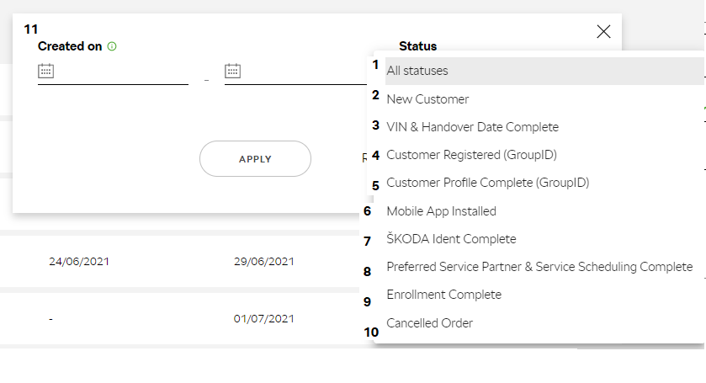

1. All statuses
2. New Customer
3. VIN & Handover Date Complete
4. Customer Registered (GroupID)
5. Customer Profile Complete (GroupID)
6. Mobile App Installed
7. ŠKODA Ident Complete
8. Preferred Service Partner & Service Scheduling Complete
9. Enrollment Complete
10. Cancelled Order

You can also narrow down the filter by the date the customer profile was created in CBA (11). Select you desired filter and / or date and click “Apply”.

## CBA – search for customers

Apart from the filters, the CBA allows the dealer to search manually for a customer based on several attributes: Commission Number; Name and/or Surname; Nickname; VIN. Type one of these into the search field and click on “Search”.

Note: Be aware, the search does not include the diacritics.

#### Figure 5 – Search Field and Results

# Connect Boarding Application – Create New Customer

To create a new customer in the CBA, please follow these steps:

1. On the top of the Home Page, select “Create New Customer”. This will initiate the process.

#### Figure 6 – “Create new Customer” button

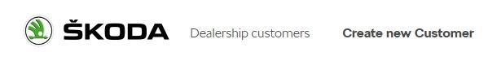

1. Enter the customer’s email address and click the “Create New Customer” button.

#### Figure 7 – Email Field

## Customer Information

#### Figure 8 – Customer Information

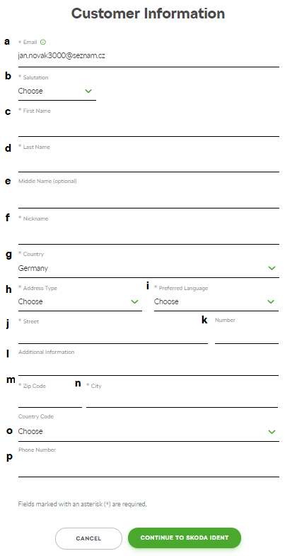

1. On this page, you need to fill in some information about the customer. The fields are:
   1. Email – prefilled from the previous step. (You can change it here, as you will not be able to change it later.)
   2. Salutation – select from the dropdown
   3. First Name
   4. Last Name
   5. Middle Name (optional)
   6. Nickname
   7. Country – is prefilled based on the dealer’s market where he is signed in. Country can be changed based on the dropdown menu.
   8. Address Type – select from the dropdown menu
   9. Preferred Language – select from the dropdown menu
   10. Street
   11. Number
   12. Additional information (optional)
   13. ZIP Code
   14. City
   15. Country code (international dialing prefix) – select from the dropdown menu
   16. Phone number
2. Click on “Continue to ŠKODA Ident”. At this point, you also have the option to cancel the creation of a new customer – just click on “Cancel”.

## ŠKODA Ident

#### Figure 9 – ŠKODA Ident

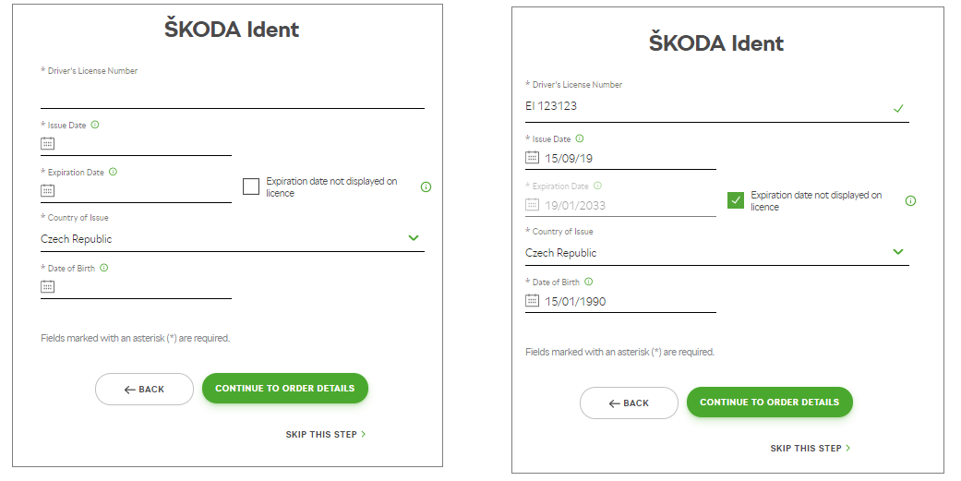

1. ŠKODA Ident is not a mandatory step. If the customer wants to complete it, please fill in the following data and click on “Continue to Order Details”:
   1. Driver’s License Number (of the customer)
   2. Issue Date – date must not be in the future
   3. Expiration Date – date must not be in the past
   4. Checkbox: Expiration date not displayed on license
      * If there is no expiration date on the driver license card, select this checkbox. The Expiration date will be prefilled based on maximum EU validity of 19/01/2033. Please, check national regulations for guidance on validity periods and if needed, enter correct expiration date.
   5. Country of Issue – prefilled based on Customer’s address country
   6. Date of Birth – the Customer must be at least 16 years of age
2. To skip Step 5, click on “Skip This Step”

Hint: A date in the date entry field can be enter manually or via calendar.

Hint: How to select correct date via calendar? To be able to find required year, click on the year to display other years. To be able to find required month, click on the month to display other months.

#### Figure 10 – ŠKODA Ident – Issue Date, Expiration Date, Date of Birth

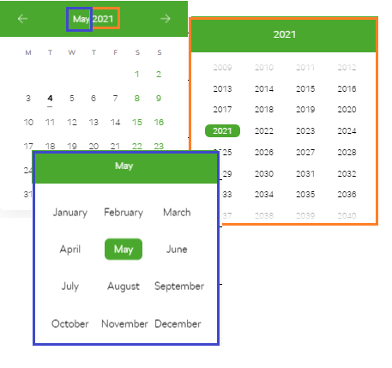

## Order Details

#### Figure 11 – Order Details

1. Fill in the order details – at this point you need to fill in the Commission Number (a) and either the Production Date (b) or the Handover Date (c). The rest of the information will be filled in later. Then, click on “Continue to Consents”
   1. Commission Number – maximum 6 digits
   2. Production Date
   3. Handover Date – date must be in the future

Hint: A date in the date entry field can be enter manually or via calendar.

Hint: How to select correct date via calendar? To be able to find required year, click on the year to display other years. To be able to find required month, click on the month to display other months.

#### Figure 12 – ŠKODA Ident – Production Date, Handover Date



## Consent Verification

#### Figure 13 – Consent Verification

1. Tick the boxes next to the consents given by the customer. Make sure all three consent boxes are marked before continuing. If the customer requires a printed copy of the consent documents, click on “Print Documents”. At this point, you also have the option to abort the process by clicking on “Cancel New Customer” on the bottom of the page.
2. After the necessary consent is given, click on “Create New Customer” to complete the initial process.

## Customer Journey

In case you need to view or edit a customer’s details, find the customer either via search or filter and click on them. This will show you their details. The “Customer Journey” section shows which mandatory areas have been completed (faded and with a green completion sign) and which ones require more information (still active).

#### Figure 14 – Customer Journey Screen

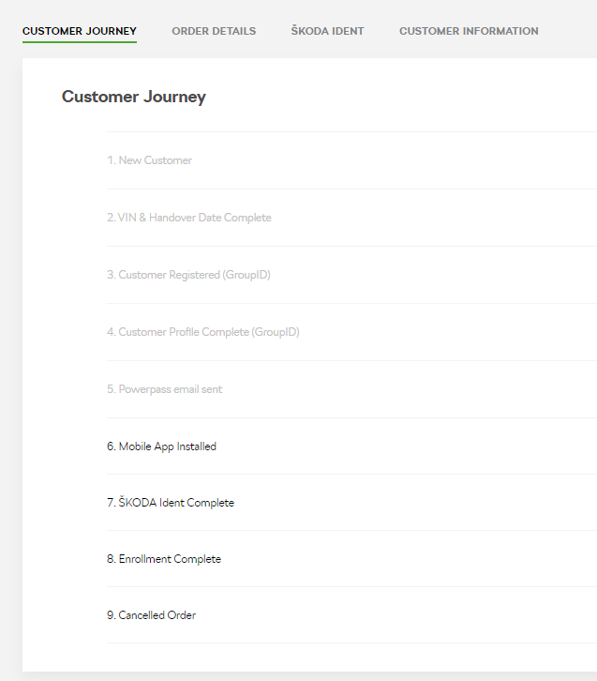

# Connect Boarding Application – Edit Customer Details

#### Figure 15 – Edit Customer Information Starting Page

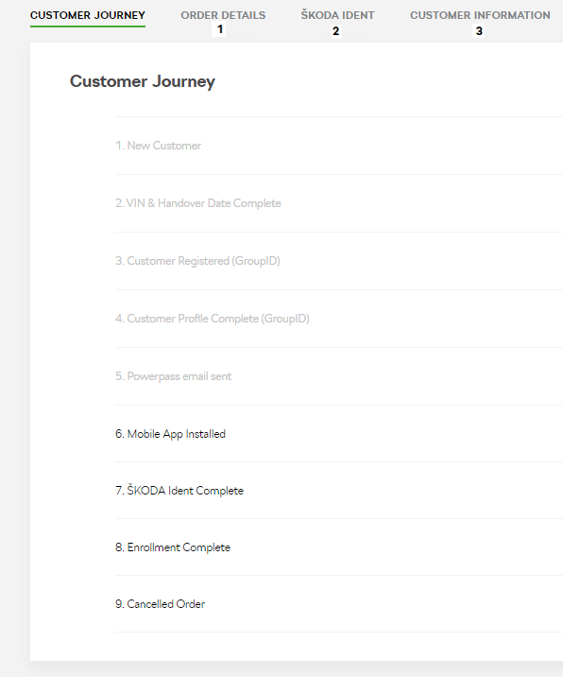

You have the option to change some customer details and add more information to their profile as it becomes available. Find the customer you need via search or filter and click on them. Check what information is missing in the Customer Journey or select a general area:

1. Order Details
2. ŠKODA Ident
3. Customer Information

## Change Order Details

You can perform more than one change at a time. Find the customer, select “Order Details”, click on “Update Information”, enter the changes and click on “Save”. (The green button will be changed from “Update Information” to “Save”.)

#### Figure 16 – Change Order Details

### Change VIN Number

Find customer 🡪 Order Details (1) 🡪 Update Information 🡪 Enter the VIN number (a) 🡪 Save

Note: VIN and Commission Number fields are no longer editable when the first invitation email is sent to the customer. The fields are locked for edit from this time.

### Change Production Date

Find customer 🡪 Order Details (1) 🡪 Update Information 🡪 Enter the Production Date (b) 🡪 Save

### Change Handover Date

Find customer 🡪 Order Details (1) 🡪 Update Information 🡪 Enter the Handover Date (c) 🡪 Save

### Change Preferred Service Partner

Find customer 🡪 Order Details (1) 🡪 Update Information 🡪 Enter the Preferred Service Partner (d) 🡪 Save

### Select Service Scheduling

Find customer 🡪 Order Details (1) 🡪 Update Information 🡪 Enter the Preferred Service Partner (d) 🡪 Mark “Service Scheduling” (e) 🡪 Save

## ŠKODA Ident

As stated above, this is not a mandatory action, but if the customer opts in, then all fields must be filled in. Find the customer, select “ŠKODA Ident” (2), click on “Update Information”, do the necessary changes and then click “Save”. (The green button will change from “Update Information” to “Save”.)

#### Figure 17 – Change ŠKODA Ident

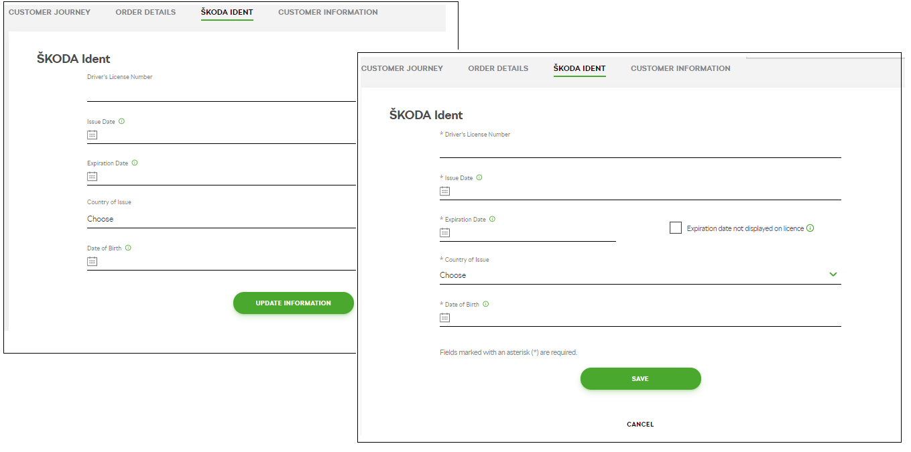

## Customer Information

You can perform more than one change at a time. Find the customer, select “Customer Information”, click on “Update Information”, enter the changes and click on “Save”. (The green button will change from “Update Information” to “Save”.)

#### Figure 18 – Change Customer Information

Note: If the customer has already ŠKODA ID created, customer’s details are no longer editable.

### Change Email

You can no longer change the customer’s email at this point.

### Change Salutation

Find customer 🡪 Customer Information (3) 🡪 Update Information 🡪 Change the salutation (Mr or Mrs) from the dropdown menu (b) 🡪 Save

### Change First Name

Find customer 🡪 Customer Information (3) 🡪 Update Information 🡪 Change the customer’s first name (c) 🡪 Save

### Change Last Name

Find customer 🡪 Customer Information (3) 🡪 Update Information 🡪 Change the customer’s last name (d) 🡪 Save

### Change Middle Name

Find customer 🡪 Customer Information (3) 🡪 Update Information 🡪 Change the customer’s middle name (e) 🡪 Save

### Change Nickname

Find customer 🡪 Customer Information (3) 🡪 Update Information 🡪 Change the customer’s nickname (f) 🡪 Save

### Change Country

Find customer 🡪 Customer Information (3) 🡪 Update Information 🡪 Change the country from the dropdown menu (g) 🡪 Save

### Change Address Type

Find customer 🡪 Customer Information (3) 🡪 Update Information 🡪 Change the address type from the dropdown menu (h) 🡪 Save

### Change Preferred Language

Find customer 🡪 Customer Information (3) 🡪 Update Information 🡪 Change the customer’s preferred language from the dropdown menu (i) 🡪 Save

### Change Street

Find customer 🡪 Customer Information (3) 🡪 Update Information 🡪 Change the street name (j) 🡪 Save

### Change Number

Find customer 🡪 Customer Information (3) 🡪 Update Information 🡪 Change the street number (k) 🡪 Save

### Change Additional Information

Find customer 🡪 Customer Information (3) 🡪 Update Information 🡪 Change the additional address information (l) 🡪 Save

### Change ZIP Code

Find customer 🡪 Customer Information (3) 🡪 Update Information 🡪 Change the ZIP Code (m) 🡪 Save

### Change City

Find customer 🡪 Customer Information (3) 🡪 Update Information 🡪 Change the city (n) 🡪 Save

### Change Country Code

Find customer 🡪 Customer Information (3) 🡪 Update Information 🡪 Change the country dialing code from the dropdown menu (o) 🡪 Save

### Change Phone Number

Find customer 🡪 Customer Information (3) 🡪 Update Information 🡪 Change the customer’s phone number (p) 🡪 Save

# Group Retail Portal

## Creating an account

Visit the GRP home page <https://grp.global.volkswagenag.com/>and click on “Create a New Account (Live).

#### Figure 19 – GRP Home Page

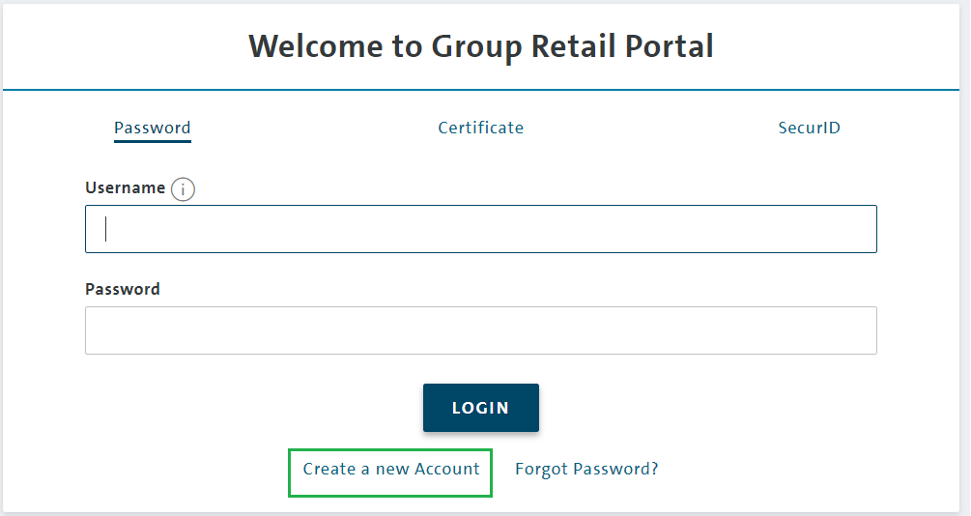

Fill in all the mandatory fields, agree to the Terms and Conditions and click “Register”

#### Figure 20 – GRP Registration

You will receive an automatic confirmation with the list of next steps and will be able to login for the first time.

## Request working context

After you login, select “Request Working Context” from the dropdown menu on the top right of the page and fill in the following mandatory fields:

* Organization type – Importer or Partner (Partner = Dealer)
* Country code (e.g. CZE or DEU)
* BID/Partner Key
* Brand (e.g. C = ŠKODA)

After that click on “Search”. If the details are correct, the system will allow you to click on “Request”. The local GRP administrator will receive your request and approve it.

#### Figure 21 – Request Working Context

## Assigning a GRP role

The local GRP administrator will assign the correct RoleID to the user based on the information they have.

## TOTP access and initial login to CBA

Request TOTP access by writing an email to your GRP administrator. They will send you back an email with 7 steps. Go directly to Step 2 and perform the actions below. In the meantime, you will also receive an email with a TOTP number (format: XXXX-XXXXXX). You will need the six digits after the dash.

1. Log in to GRP
2. Click on TOTP Login and add the 6 digits from the number provided.
3. The next page will provide you with a QR code and a 16-digit alphanumerical code – print this page and keep it safe
   1. If you are using a mobile device, you will use the QR code
   2. If you are on a computer, you will use the 16-digit code
4. Download a reliable authenticator:
   1. For mobile – Google Authenticator or Microsoft Authenticator
   2. For PC / Mac download the GRPAuth – a link will be provided in the email with the 7 steps by your GRP administrator
5. Open GRPAuth and click on “Add”. You will be redirected to “Add account”
6. Enter the account name (your choice what you name it)
7. Enter the 16-digit code
8. Enter your GRP password – you will be asked to do it 2x – and click “OK”
9. Double click on the account name and enter your GRP password
10. A 6-digit one-time password (OTP) will be generated in the format XXX XXX – memorise it or write it down but ignore the space between the digits. It lasts for 30 seconds.
11. In the GRP – you should still be on the page with the QR code – click “Continue”
12. On the next page, enter the 6-digit OTP and click “Verify”
13. The process is complete, and you will be redirected to the CBA

## CBA login for registered users

1. Open the GRP and find Connect Boarding Application within the applications designated for your access rights and working context. Click on it.

#### Figure 22 – App Screen

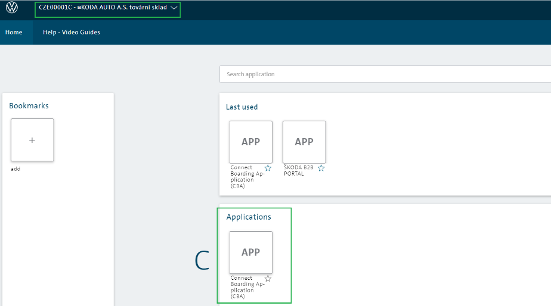

1. Select “TOTP Login”

#### Figure 23 – TOTP Login

1. Open the authenticator and generate a 6-digit OTP

#### Figure 24 – GRP Auth

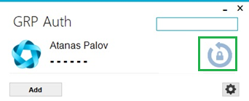

1. Enter your GRP password into the authenticator when prompted and it will generate the OTP. Enter the OTP in the TOTP login page and click “Verify”. If it is correct, you will be automatically redirected to the CBA.

#### Figure 25 – GRP Login

# Consent to personal data processing for the purpose of ŠKODA Connect User pre-registration by ŠKODA Dealer

Based on the legal’s requirements, there is a duty to receive the customer’s approval. It is on the market’s decision if the approval will be ensured by two checkboxes in the ordering form or via paper to be printed from CBA when the customer’s profile is being created.

## Ordering form contains checkboxes with customer’s agreement

There should be two checkboxes added in the vehicle ordering form with a customer’s approval to prepare activation of ŠKODA Connect services in the vehicle and agreement with default setup of Preferred Service Partner and Service Scheduling activation.

#### Figure 26 – Consent in ordering form

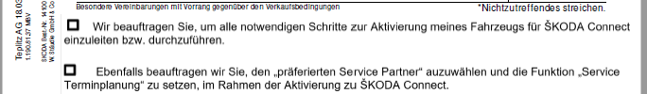

## Consent to be printed from CBA

During the customer’s pre-registration, when the dealer creates a customer’s profile, the consent should be printed and signed by the customer to receive the customer’s approval with

* Personal data processing for pre-registration (checked by default)
* Personal data processing for ŠKODA Ident purposes (obligatory for identity verification)
* ŠKODA Connect user preregistration (checked by default)
* Setting Preferred Service Partner and Service Scheduling setup (obligatory)

The consent has to be signed by the customer and by the dealer as well. The dealer has to rubberstamp the consent, so there is an address of the dealership to which the customer gives an approval. The consent has to be saved as the regular process of storing the customers’ approvals.

#### Figure 27 – Consent printed from CBA during a customer’s profile creation

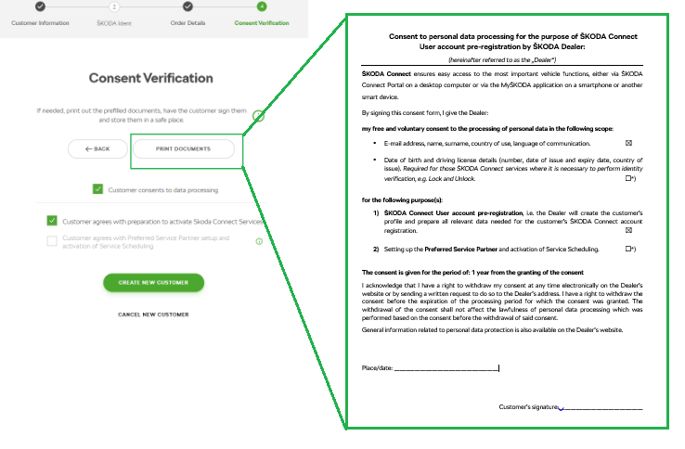

#### Figure 28 – Consent printed from CBA from footer

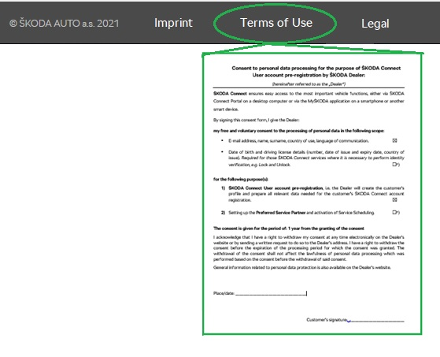

# Support Process

## USER Help Desk and ŠKODA Connect Support

Support process follows current solution with slight change in the current process.

* In case the user has an issue with CBA applicationitselfor any hardware, browser settings, connection issues etc., contact the **User Help Desk.**

**What is new?** For CBA issues, use the **CBA checklist** and provide all necessary details to the User Help Desk colleagues.



* In case the user has an issue related to any ŠKODA connect issue(e.g. enrollment issues, Preferred Service Partner setup etc.), contact **ŠKODA Connect support**

#### Figure 29 – Support Process

